University of the Cordilleras

College of Information Technology and Computer Science

Master in Information Technology

-

Dynamic Optimal Inventory Management System for Businesses

-

Dayrit, Al Ryan G.

Diaz, Ceazar Jay

Orsolino, Abigail

Soriano, Ajireh Ramielle

2nd Trimester, SY, 2019-2020

**CHAPTER I**

**Background of the Study**

On this day, there are still small businesses / companies who still use manual systems. In general, many companies used to store goods or products. In these, if the user wants to locate any product it is very difficult, because users have to do a detailed search manually in all the available stockrooms this requires a lot of effort.

The problem with those having manual systems is that it is manual. There are disadvantages of not having automated systems. There would be user error, which would lead to problems. This would also be time consuming since some people are slow and don’t know what to do sometimes. And would probably lead to inefficiency in the system [2].

To avoid these problems inventory systems are playing a major role in industries, home, colleges, and other native environments. In the smart systems, there is a linear growth in the localization concept, because localization is playing a crucial role in contemporary life [3].

The research focuses on the 9th Goal which states Industrial innovation and infrastructure. The goal covers mainly the various industries that rely on investments in infrastructure and altering drivers for economic growth and development [1].

The research also aims to develop a user-friendly software that allows persons from different industries make Automated Inventory Systems (AIS) with just a few clicks. (provide additional information) This enables the system for easier organization of in and out products/stocks as well as to produce a fast and reliable search engine for product specifications. Lastly, the AIS will help make predictions through forecasts and statistical calculations that provide accurate information as a result.

Most likely that there is a basic replenishment cycle time, each item’s procurement interval is positive multiple of the basic replenishment cycle time. [4] It is widely acknowledged in literature that the design of Inventory Management Systems is of significant importance for the overall performance of manufacturing companies [5].

**1.1 Introduction**

The Retail Industry is the Inventory System (IS) of the company that we’ve chosen. The role of this type of IS is that it helps the company to increase the company’s ability to respond to the evolving marketplace through enhanced speed and flexibility. It also helps the company To collect and analyze customer data while enhancing differentiation and to improve their business processes.

Retailing Industry involves the selling of goods to customers. While meeting the needs of customers. Retailing is a distribution channel function where one organization buys products from supplying firms or manufactures the product themselves, and then sells these directly to consumers. A retailer is a reseller (i.e., obtains product from one party in order to sell to another) from which a consumer purchases products.

The Benefits of Retailers are; It has Access to Customers - For suppliers, the most valuable benefits provided by retailers are the opportunities they offer for reaching the supplier’s target market, building product demand through retail promotions, and providing consumer feedback ﻿and Access to Products - For consumers, the most significant benefits offered by retailers relate to the ability to purchase products that may not otherwise be easily available if the consumers had to deal directly with product suppliers. In particular, retailers provide consumers with the ability to purchase small quantities of a wide assortment of products at prices that are considered reasonably affordable.

**Review of Related Literature**

Management system is the framework of processes and procedures used to ensure that an organization can fulfil all tasks required to achieve its objectives. In recent times, most organizations will opt to use a management system in their daily business tasks.

There are those who still use the non-computerized system as opposed to the computerized management system. The non-computerized system may be effective but it also causes greater task load when implemented. Computerized systems make it easier for users with functions such as searching, automatic calculation, and display of related information with minimal queries.

Manufacturers and trade resellers can both benefit from a thorough solution, where single transaction entry records necessary details on the customer, products purchased, price and date while also updating inventory levels.

Using computerized sales and inventory systems allows for much greater accuracy in stocking and product management. They encourage ease of interaction between employees and shoppers as transactions are processed and items move from the business to the consumer. Computerized sales help provide better insight into which products are most popular. It also allows for enhanced marketing, stocking and oversight of critical sales objectives.

Computerized sales and inventory systems save time for businesses by speeding up transactions while raising accuracy. This allows for confidence in accounting and accountability among employees as it is easy to verify how much money and what time transactions took place.

They also allow for consistent experiences in terms of customer service. People know there is always a uniform interaction at the register that requires tendering payment, taking a receipt and transition of ownership of products and services. This generates confidence in a business and ensures ongoing consumer relationships. Computerized systems are the most common method of inventory control and sales processing in retail markets.

In using this computerized sales and inventory system you can establish the benefits you and your business handling may have. First is time savings. The amount of time that can be saved by a business is perhaps the biggest benefit of using a computerized inventory system. In cases where a shop maintains all data manually, its manager must reconcile each sales receipt with every piece of physical inventory. Depending on the size of the establishment and how many different products are sold, this can be a daunting and time consuming task. If that same store, however, used a computerized point of sale or POS System, the master inventory list would be updated electronically each time a sale is made. The only thing a manager would have to do each day is print out the report highlighting the inventory to be restocked. Second is accuracy. An additional benefit of using a computerized inventory system is the accuracy it ensures. When an inventory list is maintained by hand, the margin of error widens with each update. If one mathematical calculation is wrong or one typo is made, disaster may occur. And lastly is the consistency. A small business operates most efficiently when its processes are executed in a consistent manner. By using a computerized inventory system, a business owner can ensure that all orders, reports and other documents relating to inventory are uniform in their presentation, regardless of who has created them. This will allow ease of reading. In addition, uniformity creates a professional appearance, which can go a long way to impress associates, such as potential investors.

**7-Eleven Inventory Management System**

In a post of 7-Eleven about their Inventory Management System in 2016, they showed the benefits of these to their franchisees and why the system matters. The company uses a real-time inventory management software which shows the 7-Eleven Franchisees which products are selling and which aren’t, enabling them to optimize their product selection and automate the restocking process. The system also automatically records replenishment rates and creates statistical recommendations relevant to a specific store and neighborhood and this results in huge profits since they know what the current trend is and what products the customers like.

**1.2 Business Rules**

**1.3 Business Process**

**Narrative description**

An inventory information system is the combination of inventory management software and inventory management processes & procedures to connect, track and manage the flow of goods, activities, information and resources across a business.

**Designing and creating I.S.**

1. The admin/manager will create an inventory system according to the type of their business and design it according to their will.
2. The employees are the one to manage the inventory system.
3. Each employee who handle the inventory system are required to create an account and fill up necessary requirements, and the information of the employee will directly store on the database

**Managing Customer Inquiries**

1. The employee will manage the customers inquiries.
2. a. if the ordered product of the customer are out of stock, the employee will update the inventory system and it will directly notify the admin.

2.b. otherwise, the employee will give the ordered product and process the payment, then the employee will update the inventory, and check if the sold product need restocking, if yes then the inventory system will send a notification to the admin.

1. The admin/manager will then reschedule/ process the restocking, and will manage the delivery of the products.

**1.4 Business Process Diagram (Flowchart)**

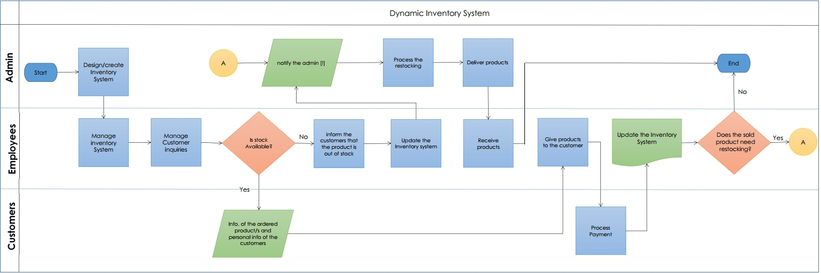

**1.5 Objectives of the Study**

The business processes that we want to analyze are [Administration](https://simplicable.com/new/administration), Sales and Operation Planning, Information Security, Marketing, Sales and Customer Service. Administration is where the on-boarding new employees and providing them an id to access the system and with that id they will do different roles. Sales & Operations Planning, a plan-to-inventory process includes all the steps required to [plan inventory levels](https://simplicable.com/new/sales-and-operations-planning) based on factors such as customer demand and production capacity. [Information Security](https://simplicable.com/new/information-security), An information security audit method checks for vulnerabilities in systems like access management lists that embody unused or inessential permissions. [Marketing](https://simplicable.com/new/marketing), An idea-to-offering process includes everything required to [develop](https://simplicable.com/new/product-development) and launch a new product to market. [Customer Service](https://simplicable.com/new/customer-service), A [customer service](https://simplicable.com/new/customer-service) process investigates customer complaints and determines if customers are owed compensation. The process also drives improvement to the organization as failures may be logged as problems and fixed.

The objective of this research is to help companies to be more organized and to improve their business processes. This research will help them to increase the company’s ability to respond to the evolving marketplace through enhance speed and flexibility. Also, this will help the company to be more productive.

//3-4 enumerated

**Chapter 2**

**System Analysis**

**2.1 Problems Encountered (Inefficient Inventory Process System)**

**Manpower**

With the exception of some very small businesses, such as sole proprietorships, company manpower is a critical issue. Manpower impacts everything from production to client relationships so managers pay careful attention to the number of workers a business engages at any given time. The importance of company manpower is best understood by looking at its benefits in depth.

The link between manpower and company projects is fairly simple: Manpower is proportional to productivity. The more people are available to work, the faster workload can be completed or the more workload a company can take on. Conversely, a lack of adequate manpower prevents businesses from completing tasks. The lack of productivity translates into a reduction in revenue and profit, which in some cases means the business can’t stay operational. When a company doesn’t have enough workers, workers generally do not need to work a high number of overtime hours. The assigned workload is more appropriate because there are more people to handle tasks. As a result, workers usually are less stressed and more rested and alert.

**Methods**

Some companies has a problem with their current methods regarding the stocks and sales that they’re using, first is time consuming and manual operations, which gives up a lot of time where they write everything down on a logbook which is not advisable when they’re dealing with a lot of stocks, simply writing it down within a logbook will cause them to lose track with the stocks and quantity of their products being stored when there’s an unexpected incident happen.

**Materials**

As said within the method, they use a logbook which is not advisable to store all the products that are being stored inside their company, also there’ll be no back-up ones it is lost.

**Machine**

As for the machine, some of the companies are not currently using machines which is not a good thing since there are products that are constantly being changed also with the prices fluctuating they need to have a system or a machine where they can store and edit the products once it is changed.

Ishikawa Diagram

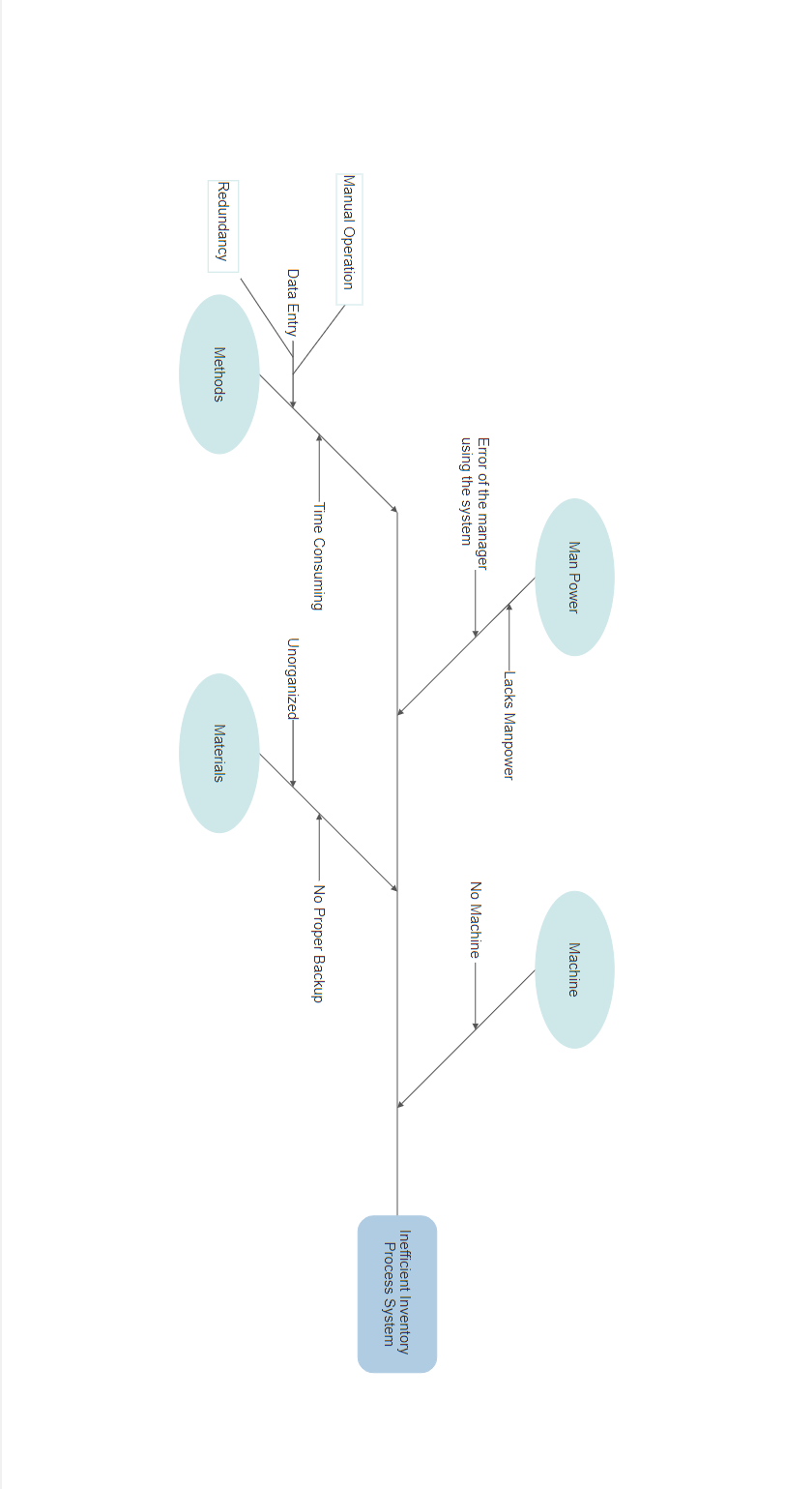

**2.2 Proposed Solution**

**Manpower**

when enough workers are on the clock, there are more people to check adherence to safety regulations and policies, and workers can seek assistance for physically challenging work. A good level of manpower thus helps prevent problems such as burnout and injury.

When the level of manpower in a company is adequate, the business has more options in how it operates. It has some flexibility in terms of which employees cover shifts; it is easier to get people to fill in. The company also has a greater pool of workers with which to construct strong teams and is more likely to have employees with the skills, knowledge and abilities to tackle current company problems. Additionally, the company has more employees who can give their own ideas and perspectives. It therefore may have an easier time remaining innovative and competitive.

Good manpower allows companies to keep the production and delivery promises they make. If companies do this, they can establish and maintain good client relationships. This can lead to additional sales. At the same time, keeping promises can prevent companies from having to pay fines and penalties, which keeps the amount of profit higher.

**Methods**

The proposed system will help the company who are using manual operations to Reduce manual and labour Inaccuracies, gives Real-Time Inventory Levels, Improves Internal Stock Handling Efficiency, and will Optimize your Logistic Workflow. Inventory management is relevant to many aspects of a business, it can contribute greatly to success when done well. Businesses with larger inventories to manage and higher turnover of product, generally favor what's called a perpetual inventory system. This type of system keeps track of your sales and orders in real time, updating your inventory count with every transaction. That's where the benefits of computerization show up most clearly.

**2.3 Functional Requirements**

The Features of our proposed system is that they can sign-up, login, system verification of accounts, view stocks, view reports, and Add Sales. The actor will be the employee because they will be the user of the system. Each employee must use the sign up feature first to make a new account and will be used in the login feature to access other features. Login feature is where the employees enter their username and password for them to be able to access the other features. Login feature is included in verify user feature because every input of the employee verifies the user if the employee has already signed up and their username and password are in the database, otherwise they cannot be able to access the other features that are included in Login feature. The features that are included in login feature are view stock, view reports, and add sales. These features are included in the login feature because for the security of the data. In view stock the employee would be able to see the name, price, quantity and the status of products, also in status it indicates if the quantity of the product is enough and if not they need to restock. For the view reports it shows the sales of product where they can be able to see the date when the product was bought, the customer's name, the receipt no., the name of the product, the quantity and total price. It will also show the most bought product and they can also see the details of the restock like date of when did they restock and the quantity of product. And to add sales features, the employee will input the name of the customer, receipt number, the product name, the quantity, the price, and the date when it was bought.

**2.4 Non-Functional Requirements**

1. **Security and Access**
   1. Admin (View and Analyze reports)
   2. Employees (Add, Edit and View)
      1. More than three attempts at login and failure will produce a red flag to the system administrators.
   3. Client (None)
2. **Design Conventions**
   1. User-friendly
   2. Default Design
3. **Updates**
   1. Automatic for every transaction
4. **Input Error**
   1. Input Errors will be left <blank>

**2.5 Scope and Delimitation**

The study will focus only on the inventory system of the products of every company who will be using the application and does not generate the reports of services of the companies. The proposed system can store, update, view the current stocks of the company and can also generate a list of reports.

The study consists of statistical reports such as records of stocks and the summary of sales which (daily and monthly).

In addition, only authorized personnel are allowed to access the system. The manager and other employees are given individual usernames and access codes for accessing the system. Unauthorized personnel cannot access the system.

2.6 Feasibility Analysis

**Gantt Chart**

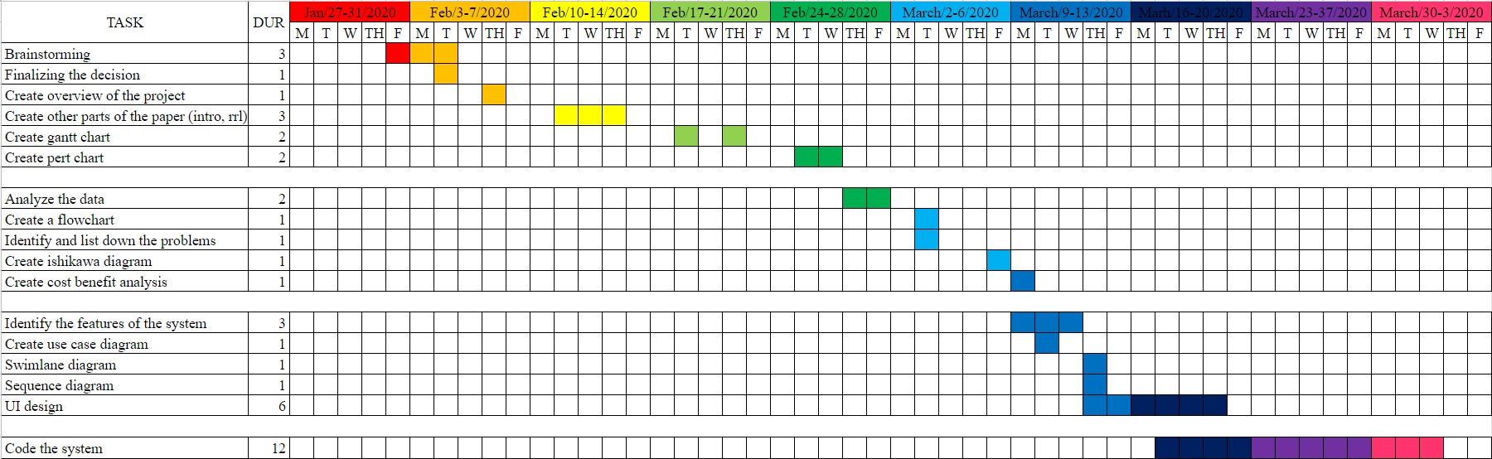

**Chapter III**

**Methodology**

**3.1 SDLC**

**3.2 Decomposition Diagram**

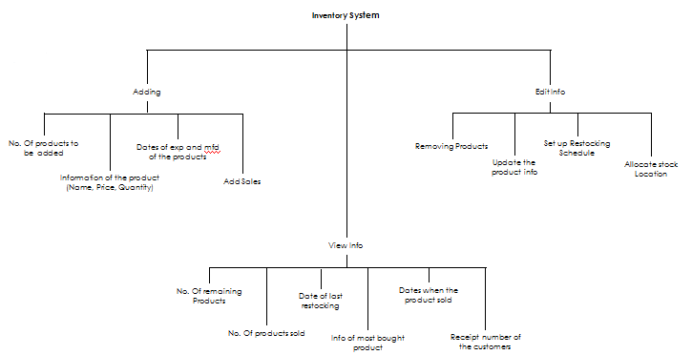

**3.3 Context Diagram**

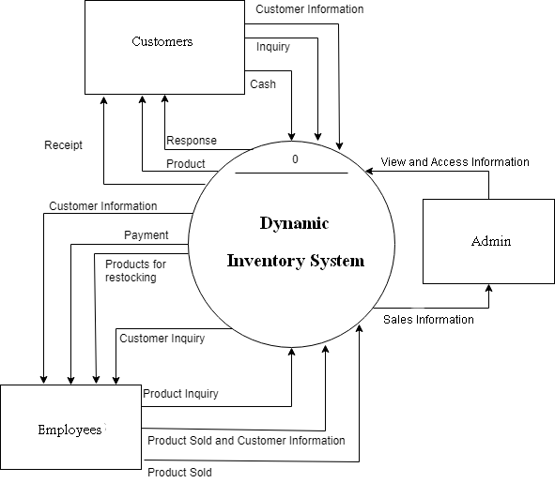

**3.4 Level Diagrams**

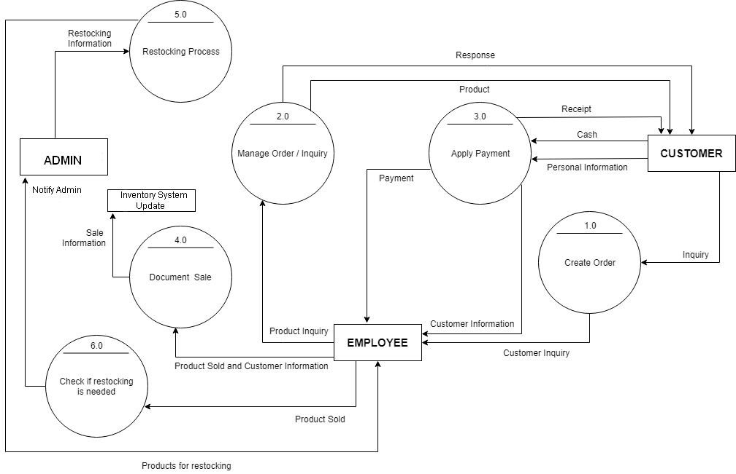

**3.5 Prototype**

Chapter IV

Conclusions and Recommendation

**Limitations and Recommendations**

Any research work has got its own limitations due to the time and resource constraints. Quality of response data and analytical tool used. These limitations give new dimensions to future research works. Some limitations of this study which have been come across during this research work and must be addressed in future research are as follows:

· The study is about the relationship between the employee and stocks. Future research may include customers also to extend the study to collaborate the findings of this study.

· The hypermarkets and departments store formats of Organized Retail Industry were considered for the research. Future research may focus on bringing in analysis and result in retail format wise.

· Future research may incorporate to establish path analysis with supplier selection and purchasing strategy design dimensions to its linkage to retailer’s overall business performance (R.H. Hoyle, 1995).

· Also for future research it will also be versatile and flexible enough for further modifications (e.g. adding an automated ID number scanner for the system for easier login).

· Finally, future research can expand the current theoretical framework by integrating new constructs beyond operational framework from managerial fields. For example, future research may incorporate “Top Management Support”, “Company Policies” and “Training and Development” in their studies to bring in new dimensions.

**References:**

[1] Goal 9: Industrial innovation and infrastructure. (n.d.). Retrieved February 11, 2020, from <https://www.undp.org/content/undp/en/home/sustainable-development-goals/>

Goal-9-industry-innovation-and-infrastructure.html

[2] Muñoz, A. (2018, October 9). 7 common online inventory management problems and solutions in industrial companies. Retrieved February 11, 2020, from <https://blog.saleslayer.com/7-common-online-inventory-management-problems-solutions-industrial-companies>

[3] S.M. Huynh, D. Parry, A. Fong, J. Tang

Home localization system for misplaced objects

Proc. IEEE International Conference on Consumer Electronics (2014), pp. 462-463

[4] Qu, H., Ai, X.-Y., & Wang, L. (2019). Optimizing an integrated inventory-routing system for multi-item joint replenishment and coordinated outbound delivery using differential evolution algorithm. Applied Soft Computing, 105863. doi:10.1016/j.asoc.2019.105863

[5] De Vries, J. (2013). The influence of power and interest on designing inventory management systems. International Journal of Production Economics, 143(2), 233–241. doi:10.1016/j.ijpe.2011.10.012

[6] Essays, UK. (November 2018). Inventory Management Literature Review. Retrieved from https://www.ukdiss.com/litreview/literature-review-on-inventory-management-with-practical-examples.php?vref=1

[7] O’Connor, T. (2016). 7-Eleven - Supply Chain Best Practices. Retreved from https://www.bestsupplychainpractices.com/2016/08/7-eleven/